

AAC Device Checklist
PART A: Identify Features

Use this form once assessment information has been gathered and you are deciding what device to trial.
This form can support teams to bring assessment information together, clarify priorities, and identify device features that best support the individual Communicator.

ESSENTIAL INFORMATION
AAC Communicator’s name |  | Date Of Birth
AAC Communicator’s Diagnosis
Team member(s) completing this form (Name, role) |  | Date form completed

HARDWARE CONSIDERATIONS (Select all that apply)
Access Method | ☐ Direct Selection (Touch access) |  | ☐ Touch accommodations (e.g. dwell, delay, activate on release)  ☐ Stylus  ☐ Keyguard  ☐ Touchguide
Access Method | ☐ Mouse |  | ☐ Head mouse  ☐ Joystick  ☐ Trackball/Trackpad  ☐ Other
Access Method |  |  | Specify:
Access Method | ☐ Scan | Switches | ☐ 1 switch |  |  | ☐ 2 switch
Access Method | ☐ Scan | Type | ☐ Button |  |  | ☐ Proximity |  | ☐ Other
 |  |  |  |  |  |  |  | Specify:
Access Method | ☐ Scan | Pattern | ☐ Linear |  |  | ☐ Row/Column |  | ☐ Block
Access Method | ☐ Scan | Feedback | ☐ Outline |  |  | ☐ Magnify |  | ☐ Invert colours |  |  |  | ☐ Auditory
Access Method | ☐ Head Tracking | Type | ☐ With head mouse (e.g. NuPoint) |  |  |  |  | ☐ With head tracking built into iOS
Access Method | ☐ Head Tracking | Signal | ☐ Dwell |  |  | ☐ Blink |  | ☐ Switch activation
Access Method | ☐ Head Tracking | Feedback | ☐ Outline |  |  | ☐ Highlight |  | ☐ Cursor
Access Method | ☐ Head Tracking | Feedback | Colour: |  |  | Colour: |  | Colour:
 |  |  |  |  |  |  |  | Style:
Access Method | ☐ Eye tracking | Active eye | ☐ Both |  |  | ☐ Left |  | ☐ Right
Access Method | ☐ Eye tracking | Signal | ☐ Dwell |  |  | ☐ Blink |  | ☐ Switch activation
Access Method | ☐ Eye tracking | Feedback | ☐ Outline |  |  | ☐Highlight |  | ☐ Cursor (pointer, cross, circle)
Access Method | ☐ Eye tracking | Feedback | Colour: |  |  | Colour: |  | Colour:
 |  |  |  |  |  |  |  | Style:
Screen size | ☐ 6-7 inches ☐ 8-9 inches ☐ 10-11 inches ☐ 12-14 inches ☐ Other  Specify:
Device purpose | ☐ Dedicated device, locked to communication app  ☐ Dedicated device, able to access other apps  ☐ Mainstream device (i.e. standard tablet is sufficient)
Operating system | ☐ Windows based  ☐ Android  ☐ iOS
Durability | ☐ Yes – added durability required e.g. frame, extreme case  ☐ No – standard mainstream protection is sufficient
Portability | ☐ Lightweight |  | ☐ Handle |  |  | ☐ Carry strap |  |  | ☐ Carry case
Positioning | ☐ Kickstand |  | ☐ Table mount |  |  | ☐ Wheelchair mount
Battery life | ☐ The ‘Locked to app’ feature stays on after battery dies

VOCABULARY CONSIDERATIONS (Select all that apply)
Language Representation Method | ☐ Semantic Compaction (i.e. Combining icons in patterns/sequences)  ☐ Single Meaning Pictures (i.e. One picture represents one word)  ☐ Alphabet (i.e. Combining letters of the alphabet)
Primary means  of message  formulation | ☐ Single/Core Words  ☐ Phrase Based (i.e. Prestored phrases)  ☐ Sentence based (i.e. Prestored sentences)  ☐ Spelling
Keyboard options | ☐ ABC  ☐ QWERTY
Vocabulary features | ☐ Consistent location of words  ☐ Vocabulary can be stored in multiple locations/pages  ☐ Word/symbol Prediction  ☐ Visual Scene Display
AI Features | ☐ Message Edit  ☐ Message Translate
Symbol set | ☐ Picture Communication Symbols (PCS)  ☐ SymbolStix  ☐ Minspeak  ☐ Other
Symbol set | Specify:
Grid size | ☐ Less than 20 cells  Optimal size: ____ |  | ☐ 20-45 cells | ☐ 46-60 cells | ☐ 60-80 cells | ☐ 80+ cells
Vocabulary settings | ☐ Hide/show  ☐ Vocabulary Builder  ☐ Search function  ☐ Guide me  ☐ Lock app (i.e. prevent changes)  ☐ Other (e.g. change button border, navigation markers etc.)
Vocabulary settings | Specify:
Languages | Specify:
Additional vocab pages | ☐ Pages for topic/activity boards  ☐ Pages for phonics

OTHER CONSIDERATIONS Select all that apply
Speech output | ☐ Voice options (e.g. adult, child, Australian voices)
Speech output | Specify:
Speech output | ☐ Ability to change speech pitch and/or rate  ☐ Speak each word  ☐ Only speak message in speech display bar  ☐ Voice banking
Supporting software | ☐ Data logging  ☐ Emulator software (i.e. external editing and backup software)
Backup method | ☐ USB  ☐ WIFI  ☐ Direct (e.g. cable)
Integration | ☐ Internal computer access  ☐ External computer access  ☐ Social media access  ☐ Email  ☐ Phone access  ☐ MP3 player  ☐ Calculator |  | ☐ Environmental controls e.g. remote controls  ☐ Bluetooth connection (e.g. hearing aids)  ☐ Device supports other AAC software
Integration |  |  | Specify:
Integration |  |  | ☐ Device supports other skill development software e.g. Look to Learn, Help Kidz Learn, Clicker, Engage etc.
Integration |  |  | Specify:
Device support | ☐ Warranty  ☐ Device Repairs  ☐ Device training/support
Funding Source | ☐ NDIS  ☐ Out-of-pocket  ☐ Charity  ☐ Other:
Funding Source | Specify:

SUMMARY / NOTES
Features to Prioritise
Tip: These go into the top row of the Part B document
Notes

Next Steps
Take the features you have prioritised (in SUMMARY/NOTES above) and put them into the top row of the Part B: Match Features document.

Need support?
If you need guidance on completing this form, or would like to hear more about feature matching, we’re here to help.
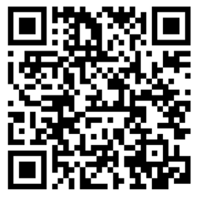
Join our App Partner Program
Liberator.net.au/
App-partner-program
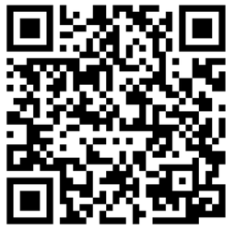
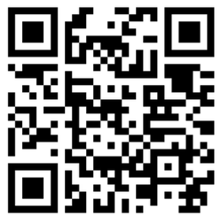
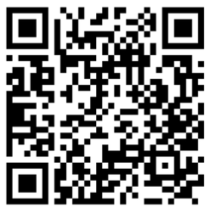

Join an upcoming Considerations for Feature Matching
FREE Webinar
Book a 1:1 Consult
Review language representation methods

Liberator.net.au/
Live-aac-training
Liberator.net.au/
contact-us
Liberator.net.au/
online-aac-training



